DO IT – Front End developer

Mini project 6 – Three column design – CSS BASICS - LAYOUT- POSITIONING

SMART d.o.o, New Frontier Group

Version: 1.0

Revision date: July 26, 2016

Table of Contents

Specification of mini project 2

Requirements for this project 3

Tasks 4

Timeline 5

Tools 6

# Specification of mini project

In this mini project you will done same page as shows in miniproject6.jpg.

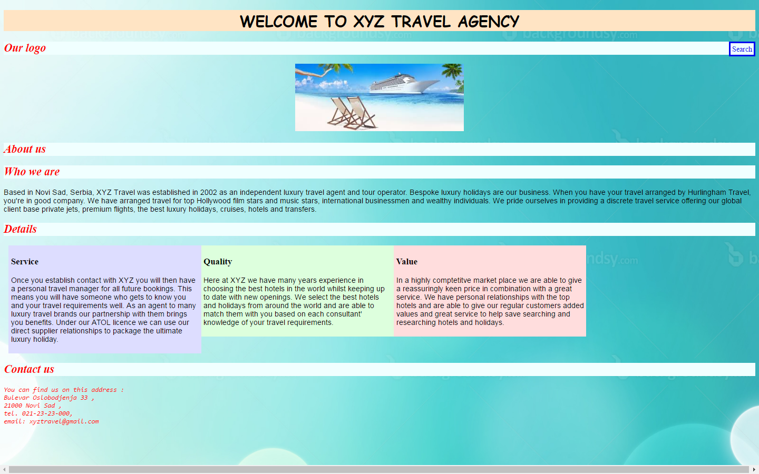

Picture 1 – miniproject6.jpg

Your job is to make some changes in web page design using CSS layout and positioning. Changes will be done on newdesign.html.

# Requirements for this project

Before you can start with this project you need to finished Introduction to CSS and CSS positioning class.

**Tasks**

So your job is to do next :

1. Use newdesign.html and style.css files as working file. You will change both of those files.
2. Open newdesign.html and find div class named details. Under this div there are three more div in which you need to make classes and call them service, quality and value respectively.
3. Under those three div there is br tag and give it class name clear.
4. Now go to the style.css under css folder. You need to make those three div service, quality and value that stands in three columns in one row but not using tables with row and columns but with using CSS only.
5. So made changes to details class selector in CSS so that has right and left margin 10 px and change width and height 100%.
6. Now create class selector service and put backgorung color as #ddf ,set width to 25% , height to 100% and padding to 5 px.
7. Next create class selector quality and put backgorung color as #dfd ,set width to 25% , height to 100% and padding to 5 px.
8. Finally create class selector value and put backgorung color as #fdd,set width to 25% , height to 100% and padding to 5 px.
9. Selector,quality and value class selector need to have float on left side.
10. After that make class selector clear and put clear property so that both left and right side be clear.
11. Save files and refresh page and see results.

**Additional tasks**

1. In style.css file change some property in details class selector and change height to 330px.
2. In service , quality and value class selector change width to 33% on each, save css file and refresh newdesign.html page.
3. See results and try to figure why this happens.
4. After that put back changes as it was before. Use CSS comments for this task to comment old and new changes.

Your result should look like on picture miniproject6.jpg

Good luck!

# Timeline

You will have 2.5 hours to finish this job.

This timeline is for main parts of the task. Bonus parts should be implemented only if there is extra time left.

# Tools

## IDE and Source Control

You can use either Atom or Brackets tool for development during this project

ATOM - <https://atom.io/>

BRACKETS - <http://brackets.io/>